Md Rashid XEBIA (Video Screening) 25th September 2025
- Introduce Yourself
- What is Redux?
- How is Redux different from React’s Context API?
- What is the recommended folder structure when setting up Redux in a project?
- In TypeScript, how can you create an interface with optional properties?
- What is a union type in TypeScript? Can you give an example?
- If your project is running behind schedule, how would you explain the delay to the stakeholders?
- If you were leading a small development team, what steps would you take to manage the project and the team effectively?
- When you have a lot of tasks in one day, how do you organize your time and work efficiently?
- How do you prioritize your work?
- How do you optimize your Javascript code.

Ashwini Yadav XEBIA (Video Screening) 25th September 2025

- Introduce yourself?
- What are React Hooks, and why do we use them?
- What are React lifecycle methods, and how do they differ?
- What is Redux?
- How is Redux different from the Context API in React?
- What is the ideal folder and file structure for setting up a Redux store in a project?
- How to make typesript optional interface?
- How do you use union types in TypeScript? Can you give an example?
- If a project is getting delayed, how would you explain the situation to the stakeholders?
- If you're asked to lead a small development team, what steps would you take to manage the team and project efficiently?
- When you have a lot of tasks to do in a day, how do you organize your work and manage your time?
- Can you explain the difference between synchronous and asynchronous operations in JavaScript?

Gyan Raj XEBIA(L-1) 30th April 2025
- What will be the output?
[2, 3, 4, 5].forEach((ele) => {
setTimeout(() => {
console.log(ele);
}, 3000);
});
2. What are the hooks have you used?
3. Can you write a code to show useState and useEffect?
4. How many times hello will be printed for the below code?
const App: React.FC = () => {
const [counter, setCounter] = useState();
useEffect(() => {
console.log("hello");
});
return (
<></>)
}
5. How many times hello will be printed?
const App: React.FC = () => {
const [counter, setCounter] = useState();
useEffect(() => {
console.log("hello");
}, [counter]);
return (
<></>)
}
6. How many times hello will be printed, and what will counter value printed?
const App: React.FC = () => {
const [counter, setCounter] = useState(0);
useEffect(() => {
console.log("hello", counter);
}, [counter]);
if (counter < 5) {
setCounter(1);
setCounter(2);
setCounter(3);
setCounter(4);
setCounter(5);
}
return (
<></>)
}
7. Write a program to swap two numbers without using 3rd variable
8. Do you know next JS?
9. What is your daily routine at work?
10. Have you led any team?
11. What will be the output and type of output?
console.log(4+2+"6"+"7"-3+6)
console.log(4+2+"6"+"7"+3+6)
12. Have you used and store management library?
13. Differentiate between useContext and redux toolkit
14. Why do we use middlewares?
Dayamani TC XEBIA(L-1) 30th April 2025
- What is script-less automation?
- Differentiate between Selenium and script-less automation.
- What is the React version you have used?
- Create a button in React where the count increases on click.
- Create a custom hook for fetching data in React.
- Given an array of 1 to 8, use reduce method to get even numbers.
- What are React hooks you have used in your project?
- Explain the useMemo hook.
- List popular CSS libraries and frameworks.
Xebia – Technical Round – Jagath J K – 10th October
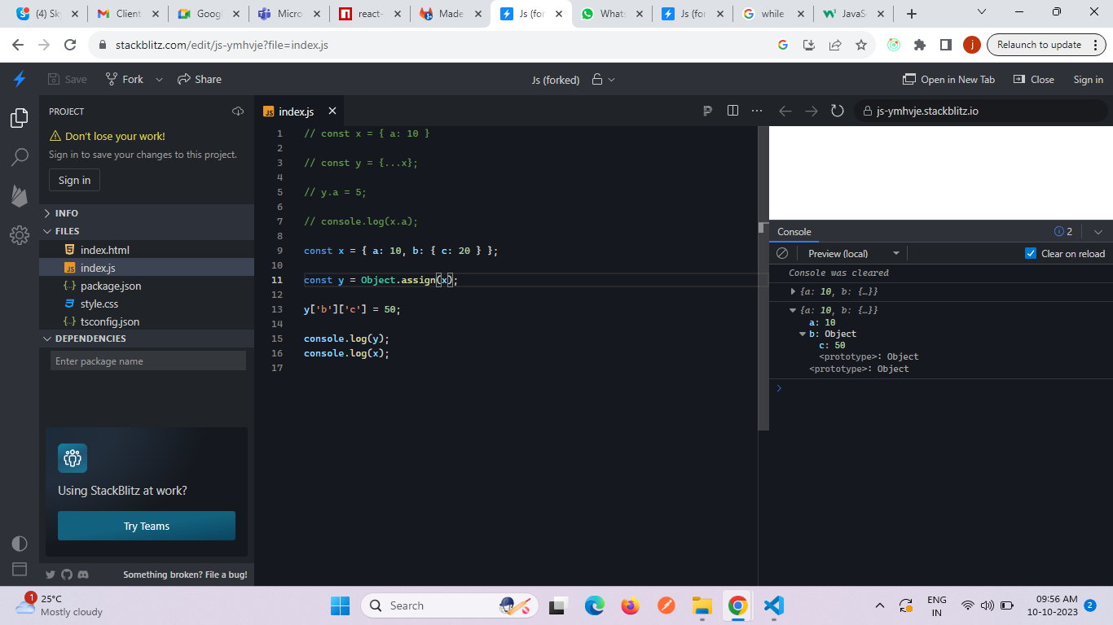
1. How to take deep copy of object if we have date formats in it?
2. What is usecallback?
3. What is usememo?
4. What is pure component?
5. Behaviour of pure component when function is passed
6. lifecycle methods in functional components
7. Do you have experience on NextJs?
Xebia – Technical Round – Jagath J K – 29th September
- Closure, scope, pure components, behaviour of pure components when function is passed
- Explain behaviour of this in normal an arrow function,
- How shallow comparison works in pure components?
- Thunk and saga
Xebia – Technical Round – Arshiya Shaikh – 29th September
1) What Are Pure Function in React?
2) How much Experience you have?
3) console.log(x);
var x=10
What will be the output of it?
4) What is Closure? Give an Example?
5) Workflow of Javascript Program?
1. Hoisting with respect to let and const
2. Es6 features
3. This keyword
4. Life cycle in React
5. UseState, useEffect, use Context difference
6. React Hooks
7. AXIOS
8. REDUX
9. How to optimize the application (How to improve the performance)
10. Test cases using JEST
11. Login functionality (JWT)
12. About Error Handling
13. Details about projects
1. Virtual DOM & Real DOM
2. Props
3. States
4. Class components
5. GIT & CI/CD
1. What is a class component and function component.
2. About Project.
3. Axios call.

